Title: Subtitle (Candara, 14, bold, line spacing 1.5, align left)

Abstract
Summary of the article's content, formatted in Candara, left-aligned, size 12, italics, and with 1.15 paragraph spacing (maximum 10 lines).
Keywords | Insert a maximum of 5 keywords, separated by commas. (Body: Candara, 10, line spacing 1.5, justified)

First section level | Left-aligned, size 16, bold
Body text in Candara, left aligned, size 12, normal, and with 1.15 paragraph spacing. One line of white space between body text and different section levels. The maximum length of the article is 10 pages (oral presentation).
Second section level | Left-aligned, size 14, bold
Body text, idem.
Third section level | Left-aligned, size 12, bold, no numbering
Body text, idem.
Fourth section level | Left-aligned, size 12, italics, no numbering; the article should not have more than four levels in a section
- Tables
- Number all tables and figures sequentially according to their order in the text (for example, Table 1, Table 2, etc.), in the same way as figures (for example, Figure 1, Figure 2, etc.).
- The table or figure number should be presented in bold, above the table or figure (e.g., Table 1).
- The title should be short and in italics, placed on the line immediately below the figure or table number (double-spaced).
- Tables are represented with numerical values or text, displayed in lines and columns.
- Reprinting or adapting a table from another printed or online source must include a copyright attribution in a note. The caption below the figure begins with the word Note in italics, followed by a full stop ‘.’ – if the figure was created from another source.
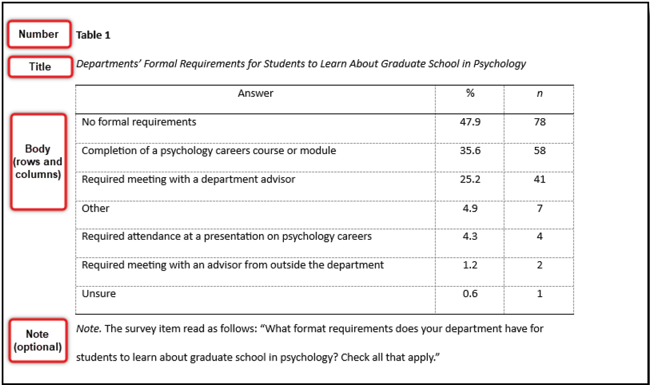
Example of a table formatted according to APA Style (7th ed.), illustrating the presentation of the table number, title, body (rows and columns), and an optional explanatory note. Adapted from Student Paper Setup Guide, by the American Psychological Association. Retrieved from https://apastyle.apa.org/instructional-aids/student-paper-setup-guide.pdf
Table 1
Brief description at the top of the table (up to 2 lines).
Example 1 | Example 2 | Example 3
Example 4 | Content 1 | Content 2

Body of text, idem.
Figures can be any image or illustration: photograph, clipart image, graph, map, drawing, diagram (Figure 1). Like tables, figures include several elements:
- Numerical identification: Identical to that of the tables (that is, numbering in the order in which they are mentioned in the text, presentation above the figure, left alignment, and bold).
- The title should be presented on the line below the numerical identification, double-spaced, in italics and in capital letters.
- Caption: Captions are not mandatory and should only be included to explain information contained in the image (e.g., explanation of the meaning of colours or patterns in a graph).
- Note: If necessary, like tables, figures may contain three types of notes (general, specific, or probability). Specifically for figures, general notes include the designation of abbreviations, units of measurement, or symbols not included in the caption.
- Reprinting or adapting an image from another printed or online source must include a copyright attribution in a note.
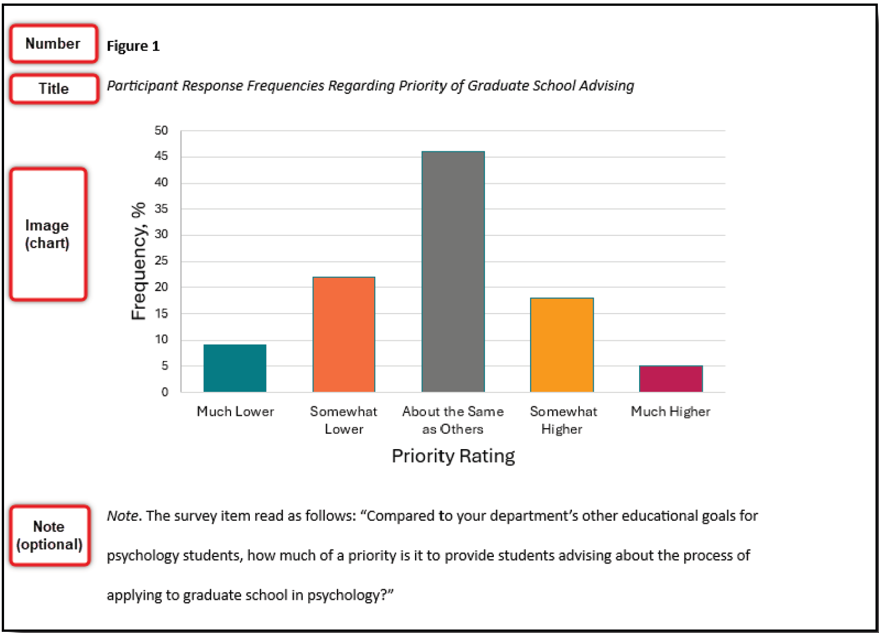

Example of a figure formatted according to APA Style (7th ed.), illustrating the presentation of the figure number, title, body (rows and columns), and an optional explanatory note. Adapted from Student Paper Setup Guide, by the American Psychological Association. Retrieved from https://apastyle.apa.org/instructional-aids/student-paper-setup-guide.pdf

Figure 1
Brief description in the figure caption (up to 2 lines).

Body of text, idem. If equations are presented, they should be aligned in the centre, on a separate line.

x + y = z

Citations and References | For citations and references, we recommend using the APA 7th bibliographic style (American Psychological Association, n.d.). For more information, please see:
How to cite and reference: A practical guide to APA standards (2020, 7th edition). http://hdl.handle.net/10400.12/8617
Example:
Zhu, J., & Liu, W. (2020). A tale of two databases: The use of Web of Science and Scopus in academic papers. Scientometrics, 123(1), 321-335. DOI: 10.1007/s11192-020-03387-8

