Title: Subtitle (Candara, 14, bold, line spacing 1.5, align left)

Name and Surname

Affiliation/Organization (Country)

author1@local.com

Name and Surname

Affiliation/Organization (Country)
author2@local.com

Name and Surname

Affiliation/Organization (Country)

author3@local.com

Abstract
Challenge, Context, and Motivation (max. 500 characters) | (Body: Candara, 10, regular, line spacing 1.5, justified)
Explain the public challenge or opportunity addressed by the prototype. Clearly identify the local governance context, target users or beneficiaries, and the public value pursued.

Objectives and Innovation Rationale (max. 500 characters) | (Body: Candara, 10, regular, line spacing 1.5, justified)
State the main objective of the prototype and explain what makes it innovative in the context of Local Public Administration.

Co-creation and Stakeholder Involvement (max. 600 characters) | (Body: Candara, 10, regular, line spacing 1.5, justified)
Explain how stakeholders were involved in the design and development of the prototype.
Methodology (max. 500 characters) | (Body: Candara, 10, regular, line spacing 1.5, justified)
Clearly describe the approach adopted, including the materials, components, digital tools, development processes, and design/engineering methodologies used.
Prototype (max. 600 characters) | (Body: Candara, 10, regular, line spacing 1.5, justified)
Explain the current operation of the prototype, including the level of technological maturity (TRL, if applicable) and the features tested. Reference the figures.
Testing, Validation, and Evidence (max. 600 characters) | (Body: Candara, 10, regular, line spacing 1.5, justified)
Present results, user feedback, laboratory validations, or practical demonstrations performed to date.
Alignment with the INNlocal Project (max. 300 characters) | (Body: Candara, 10, regular, line spacing 1.5, justified)
Briefly describe how the prototype contributes to the INNlocal Project goals.



Figure 1: Mandatory prototype image. Figures should be high quality (1200 dpi for line art, 600 dpi for grayscale and 300 dpi for colour, at the correct size). Figures should be supplied in one of our preferred file formats: JPEG, TIFF, or PNG.

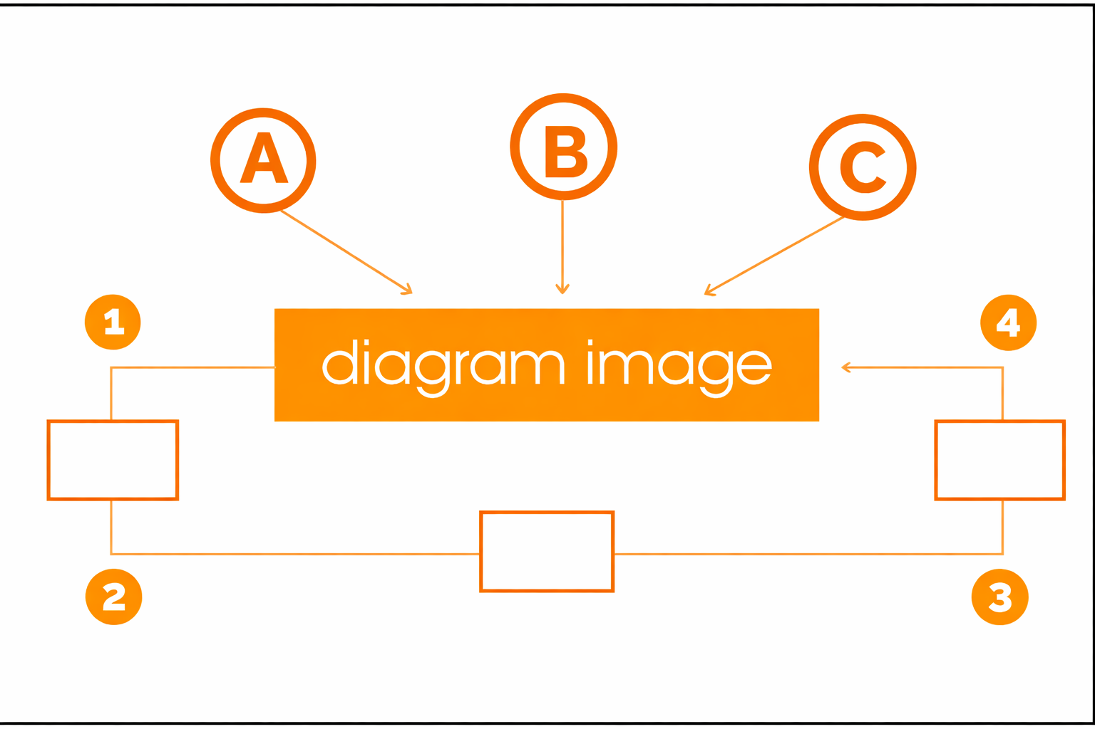
Figure 2: Mandatory process diagram. Short captions are centered, while long ones are justified. Microsoft Word (DOC or DOCX) files are acceptable only for figures that have been drawn directly in Word.

Citations and References | For citations and references, we recommend using the APA 7th bibliographic style (American Psychological Association, n.d.). For more information, please see:
How to cite and reference: A practical guide to APA standards (2020, 7th edition). http://hdl.handle.net/10400.12/8617
Example:
Zhu, J., & Liu, W. (2020). A tale of two databases: The use of Web of Science and Scopus in academic papers. Scientometrics, 123(1), 321-335. DOI: 10.1007/s11192-020-03387-8

